**SPECIAL TOPICS IN NETWORKING**

**ASSIGNMENT-3**

**Name: Sai Rohit Kalyan Gandham**

**ID: 1002070724**

**1.What are the differences between WiFi and Wireless Network?**

**Sol)**

|  |  |
| --- | --- |
| **Wi-Fi** | **wireless network** |
| **Wireless local area network is most commonly referred to as Wi-Fi.** | **A wireless connection is one that is offered by an outside network provider.** |
| **In a constrained space, it is used to connect two devices with one another.** | **In a larger area, it uses radio frequency links between nodes.** |
| **The 2.4 GHz and 5 GHz frequency bands are used by Wi-Fi.** | **Different wireless networks use different frequencies.** |
| **Wi-Fi allows us to send data from one device to another.** | **In a wireless network, data transfer between devices is not possible.** |

**2) What are the advantages and disadvantages of LoRaWan compared to NB-IoT and LTE M?**

**Sol)**

**A low power wide area network protocol is LoRaWan.It wirelessly connects devices to the internet and allows them to communicate with network gateways and end node devices.**

**Low power wide area networking techniques include LoRaWan and NB-IoT. Most people can put up their own networks at a reasonable cost using the LoRa alliance's unlicensed LoRaWan spectrum. Since NB-IoT is a licensed protocol offered by 3GGP, it can only be obtained through network operators yet offers a superior user experience.**

**LoRaWan is utilized for projects that demand greater refresh rates because it uses less power than NB-IoT. Compared to NB-IoT, LoRaWan has a longer battery life since it uses less power.When it comes to speed, NB-IoT has a peak throughput of 60 Kbps, which is higher than LoRaWan's 50 Kbps. Additionally, NB-IoT is more secure than LoRaWan because it uses 256-bit 3GG encryption as opposed to 128 bit Advanced encryption.NB-IoT has lower latency than LoRaWan since LoRaWan's latency is very dependant on the type of device and classification.**

**LTE-M uses frequency division multiple axes, whereas LoRaWAN uses chip spread spectrum modulation technology.LoRaWan has a data rate of 50 kbps, which is less than that.With that data rate, we can only receive sensor data; we cannot send video. On the other hand, the 10Mbps LTE-M data rate allows for video communication.**

**Like NB-IOT, LTE-M is licensed, thus another business must offer it. When compared to LoRaWan, LTE-M is more advantageous for long distance communication, such as intercontinental and international communication, due to its established infrastructure and flexibility. LTE-M is primarily used by the Internet of Things (IoT) to communicate with 4G without a gateway or batteries.Despite having a shorter battery life than LoRaWan, LTE-M can enter an energy-saving mode when the device is not in use. It implies that when a connection is created, it will also immediately wake up.**

**3) Why LoRa can communicate at a far distance? Using mathematical models and Figures to explain your answer**

**Sol)**

**Radio waves are transported using air using LoRa. Therefore, in a direct spread spectrum, a quicker signal with a greater frequency band width and more link budget is formed while multiplying the data signal with a pre-defined bit pattern at a much higher rate, also known as a spreading code. As a result, it is turned into a longer spectrum rather than the FM radio's limited ban**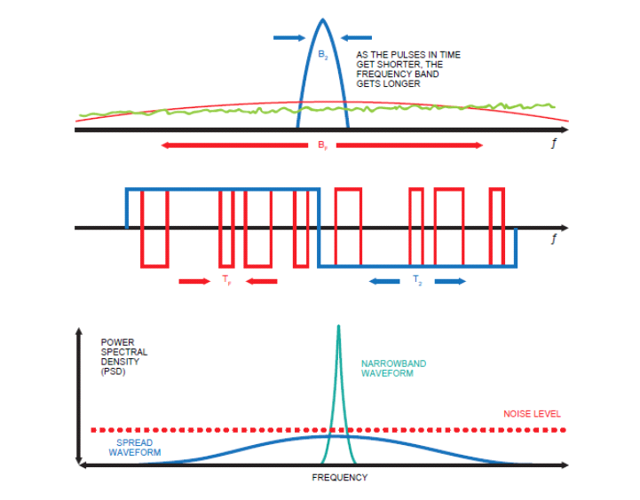

**The transmitted signal is multiplied by the exact same copy of the spreading code used in the transmitter when it reaches the receiver, creating a copy of the original signal. We may transfer the signal over a larger distance using this method.**

**GP(processing gain)=log10(chip rate/signal bit rate)**

**Even when the signal to noise ratio is negative, this method is utilized to recover the original signal from the modulated signal.**

**4). What are chirp and inverse chirp? Why inverse chirp is used to decode the symbols (data) in LoRa communication?**

**Sol)**

**A chirp signal is one that oscillates between increasing and decreasing frequencies over time, and chirp signals are always accompanied with data.**

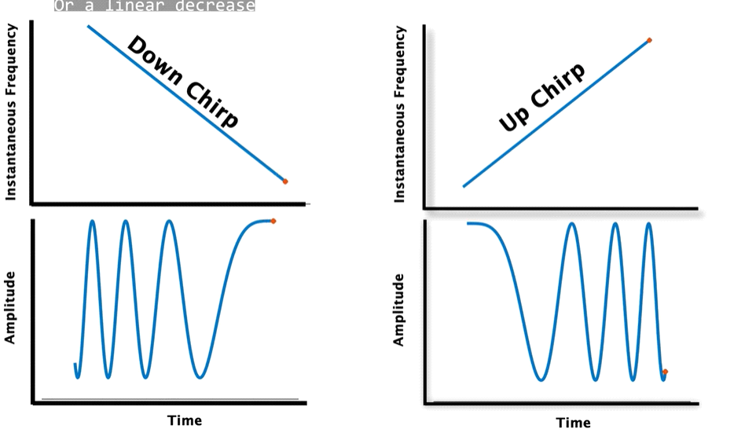

**The opposite of a chirp, which is utilized to decipher the signal at the receiver, is an inverse chirp signal.**

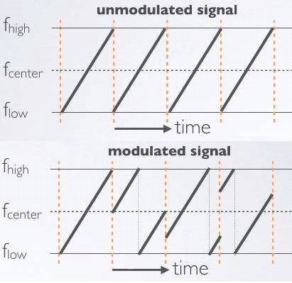

**Unmodulated and modulated chirp signals are displayed in the above graphic.**

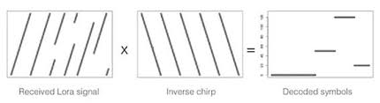

**We use inverse chirp for the demodulation.**

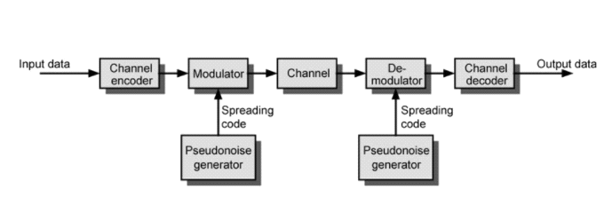

**The spread spectrum system's general flow is represented by the flow chart above. In order to modulate a signal, we use a chirp signal; to demodulate a signal, we use an inverse chirp signal; and to obtain the final output data at the channel decode, we use an FFT.**

**5). Describe one example application that can be enabled by LoRa. Explain why using Lora is better than existing Cellular, Wi-Fi communication in such application ?**

**Sol)**

* **LoRa technology has transformed the Internet of Things (IoT) by providing power-efficient, long-distance data connectivity. Sensor devices with LoRa chipsets support a wide range of IoT applications by transferring packets with crucial data when linked to a non-cellular LoRaWAN® network. Based on its extensive adoption, LoRa is the de facto IoT technology and will be used to connect the next billion IoT devices. LoRa is adaptable for indoor or outdoor use cases in smart supply chain and logistics, smart utilities and metering, smart homes and buildings, smart environments, smart cities, smart agriculture, and industrial IoT (IIoT).**
* **Because of the growing number of IoT vertical applications, LoRa devices and the LoRaWAN protocol are streamlining operations and enhancing people's lives all over the world.**
* **In the LoRaWAN network architecture, gateways employ single-hop wireless communication to connect to one or more gateways while end devices use regular IP connections to connect to the network server. All end-point communication is typically bidirectional, but it also enables functions like multicast that allow for over-the-air software updates and other mass distribution messages to cut down on on-air communication time.**
* **Other LPWAN technologies do not address the advantages of LoRaWAN protocol in terms of bi-directionality, security, mobility, and precise localisation. These advantages will facilitate the variety of use cases and business models that will increase LPWAN IoT network deployments globally.**

**6). Explaining in details the differences between RFID and Ambient Backscatter ?**

**Sol)**

|  |  |
| --- | --- |
| **RFID** | **Ambient Backscatter** |
| **Instead of creating these tags, RFID employs electromagnetic fields to recognize and track tags that are attached.** | **Radio waves are transmitted via existing TV and cellphone data in ambient backscatter.** |
| **In order to continuously send and generate radio signals, these tags need batteries.** | **This uses two battery-free gadgets that can interact with each other utilizing current tools.** |
| **The two parts of an RFID reader are used to transmit and receive radio waves.** | **Here, radio waves are generated and received by both devices using cellular or TV data that is already in use.** |
| **Although the tags are unable to interact with one another, they can with the receiver.** | **The reader and both devices are capable of communication.** |
| **Device to device communication is not offered.** | **It enables communication between devices.** |

**References:**

* [**https://www.fda.gov/radiation-emitting-products/electromagnetic-compatibility-emc/radio-frequency-identification-rfid**](https://www.fda.gov/radiation-emitting-products/electromagnetic-compatibility-emc/radio-frequency-identification-rfid)
* [**https://www.semtech.com/lora/what-is-lora**](https://www.semtech.com/lora/what-is-lora)
* [**https://enterpriseiotinsights.com/20170612/internet-of-things/what-lowrawan-main-benefits-technology-tag23**](https://enterpriseiotinsights.com/20170612/internet-of-things/what-lowrawan-main-benefits-technology-tag23)
* [**https://www.semtech.com/lora/lora-applications**](https://www.semtech.com/lora/lora-applications)
* [**https://homes.cs.washington.edu/~gshyam/Papers/amb.pdf**](https://homes.cs.washington.edu/~gshyam/Papers/amb.pdf)
* [**https://ieeexplore.ieee.org/document/1162603**](https://ieeexplore.ieee.org/document/1162603)
* [**https://en.m.wikipedia.org/wiki/Chirp**](https://en.m.wikipedia.org/wiki/Chirp)